## 

PHP Assessment

# Objective

This assessment aims to gauge your development skills with the focus being on back-end using PHP. We will be paying attention to your approach to solving the problem, the structure of your code, and adherence to best practices and design principles.

If you have any questions, please feel free to ask. It’s part of the assessment.

If you are in Sri Lanka, contact *j.perera@temper.works*, otherwise, contact *django@temper.works*.

# The Problem

Temper has just optimized the onboarding flow. After signing up for an account, the user has

to complete a series of forms to complete their account.

You can see a conceptual [Onboarding Flow](https://drive.google.com/open?id=0B9EkbaBvN76DNzdfbkV3dVhJZ2M) to get an idea.

The current steps in onboarding are:

1. Create account - 0%
2. Activate account - 20%
3. Provide profile information - 40%
4. What jobs are you interested in? - 50%
5. Do you have relevant experience in these jobs? - 70%
6. Are you a freelancer? - 90%
7. Waiting for approval - 99%
8. Approval - 100%

At the moment we don’t know how users are performing in the Onboarding Flow. We want to

know where many people get stuck, so we can make improvements.

# Business Requirement

We want to see a Retention curve chart that shows how far a group of users (weekly cohorts) has progressed through the Onboarding Flow.

* Get insight of how users flow through the onboarding process
* Get insight in how the onboarding process improves over time
* Get information on where we should improve the onboarding; where do users get

stuck?

# Development Guidelines

**Your solution**:

* The chart will similar to the examples provided at the end of this document
* The chart has one line per weekly cohort
* The vertical axis is the percentage of users who have been or are still in this step
* The horizontal axis represents the steps in the Onboarding Flow (based on the onboarding percentage)
* On the first step (X=0) 100% of the users are still active, so all charts start at X=0, Y=100%
* Use the data provided in the CSV and JSON files.
* Won't make use of a database. A proper solution allows that the csv can be swapped with a real database implementation in the future.

**Assumptions**:

* The chart is only visible for Temper admins

**Must Haves**:

* Back-end in PHP producing JSON responses to be consumed by the front-end
* Clean, maintainable, and **SOLID** code
* Represent the data in web front-end in a chart using Highcharts
* At least 50% test coverage on business logic
* Clear setup instructions using nginx, php -S or artisan serve or other
* Upload the results to github/bitbucket (ensure the repo is publicly accessible or shared with us)
* Supply a screenshot of the final result in the git repo
* Keep it simple; you should be able to finish the assessment within 4 hours

**Bonus Points for**:

* Use VueJS/React for front-end
* Use vanilla PHP on backend.

**Out of Scope**:

* Login system
* Any of the screens defined conceptual Onboarding Flow mentioned earlier
* Eye candy

Examples of Retention curve charts:

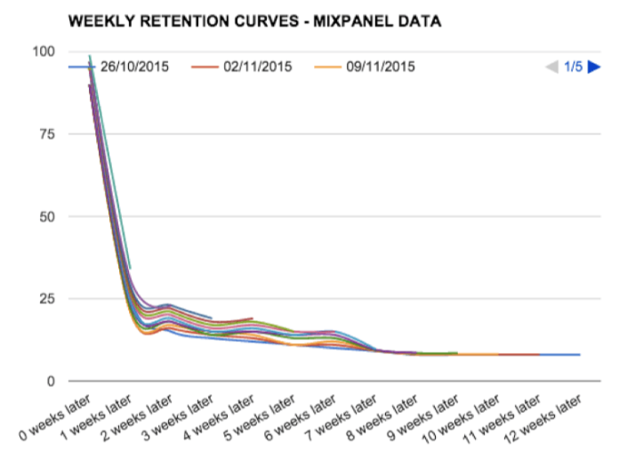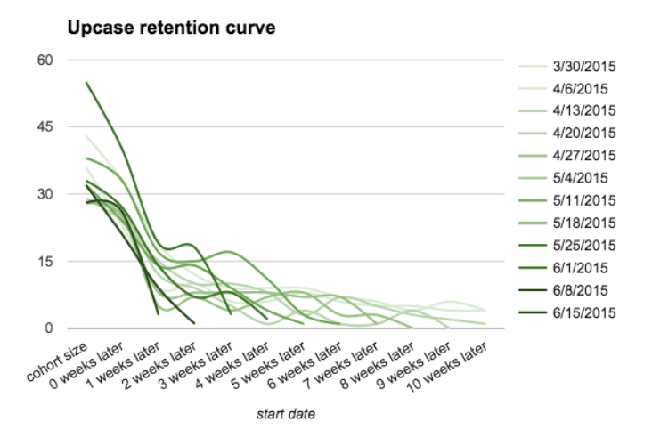

# Scorecard

Your assignment will be scored based on these points. How do you rate it yourself?

|  | **Score** | **Comments** |
| --- | --- | --- |
| The result is correct |  |  |
| The project is easy to install |  |  |
| While looking at the project I understand what it does. Class names describe what they do. |  |  |
| Shows understanding of SOLID |  |  |
| Methods are small and do what they say |  |  |
| Test-driven approach (both unit & integration) |  |  |
| Without knowing the specs, the code is understandable and maintainable by another developer. |  |  |